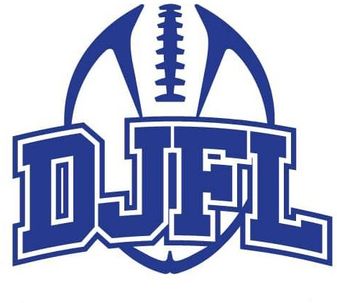

For the 2025 DFJL Football season, we are implementing a Letter of Commitment and Code of Conduct. Our goal is to ensure everyone is on the same page for the fall football season. We ask families to prioritize DJFL practices and games over other sports during the season.
Players must attend all practices and games, with exceptions for mandatory school events, bereavement, illness or religious observances. Missing practices or games without a valid reason may result in penalties, such as sitting out games or losing your spot on the team. Both players and their parents or guardians need to agree to these rules. We understand that there may be conflicts during the season, but DJFL must take priority, and any conflicts need to be discussed with your coach prior to missing any practice or games.

While we understand that other sports have become year-round, our season is very short in comparison. If you are trying out for an Elite Club Hockey, Baseball, or Soccer team, we ask that you please consider whether you can make a full-time commitment to DJFL. We encourage all youth athletes to play other sports during the year to enhance athletic development and enthusiasm for all sports while building a sense of community. However, during our short season, we require that you choose DJFL over other event conflicts. If you cannot commit to football and make it a priority, please reconsider playing, as our experience over years has shown that regular absences can become a safety issue and affect the team chemistry each week. Lack of regular attendance also presents issues when coaches prepare line-ups each week. Playing games with less than a full roster due to absences is not fair to the players who are there every day.

DJFL Letter of Commitment and Code of Conduct– Fall Football Season
Darien Junior Football League (DJFL) requires that all participants commit and adhere to the following Letter of Commitment and Code of Conduct. Players are the most important people in the sport. Playing for the team, and for the team to win, is the most fundamental part of the game. Fair play and respect for all others in the game is fundamentally important. DJFL believes in the three “S’s” – Safety, Sportsmanship, and Scholarship - and expects participants to exhibit them both on and off the field. Failure to respect and comply with the following Letter of Commitment and Code could result in disciplinary action by DJFL and/or the FCFL that may result in warnings or suspension. Always remember that the game of football will be enjoyable, fun team sport only when you conduct yourself as follows:
We, the undersigned player/parents/legal guardians of said player, by executing this Letter of Commitment and Code of Conduct agree to the following terms and conditions of this commitment:
- I/We understand that for the primary summer/fall season (e.g. End of August – Mid-November) participation in DJFL practices and games will be a priority over any other youth travel or non-travel sports, (e.g. hockey, soccer, baseball, basketball)
- I/We further understand that failure to respect and follow the terms and conditions of this Letter of Commitment, and/or any DJFL policies or procedures, may result in reduced playing time, suspension or expulsion from the team as the coach, and if necessary, Board of Directors of DJFL deems appropriate.
- I/We understand that playing time is determined by my attendance, attitude and performance at practices.
- I will attend all practices/games except for illness, bereavement, religious obligations or mandatory school events and I will notify my coach immediately if I am unable to attend a scheduled practice/game. Unexcused absences from practices or games (non-participation in a significant portion of one or more practice(s)) may be grounds for discipline, as outlined below and may result in reduced playing time.
- I/We agree to conduct myself with dignity as a participant of DJFL football community and as a citizen of Darien.
- I will be fully accountable for my behavior and its outcome. I understand that discipline problems will not be tolerated and could result in my being suspended or removed from the team.
- I/We understand that each player must demonstrate fair play and good sportsmanship at every practice and game.
- I/We understand that players and parents/legal guardians will always respect all coaches, officials, all players, and spectators.
- I/We understand that no player or parents/legal guardians will take part in form of bullying, cyber-bullying, whether to a teammate or any opposing player(s).
All grades are required to attend:
- All practices and games for their assigned team
Excused Absences* include illness, mandatory school events, bereavement, religious observances/obligations
Unexcused Absences* include play practice, dance practice, music practice, other sports, select team practices/games/tournaments (including baseball, lacrosse, soccer, hockey, crew, swimming, etc.).
*If a player anticipates missing for an excused absence, then the player should make coaches aware as soon as possible.
We have read and understand the aforementioned information regarding the commitment and Code of Conduct for participating in the DJFL and agree to follow these policies.

Print Name: ______________________________________________ Date: _________________
Athlete Signature: ________________________________________ Date: _________________
Print Name: _____________________________________________ Date: _________________
Parent/Guardian Signature: ______________________________ Date: _________________

